2O21 NEITI OIL AND GAS INDUSTRY AUDIT HIGHLIGHTS
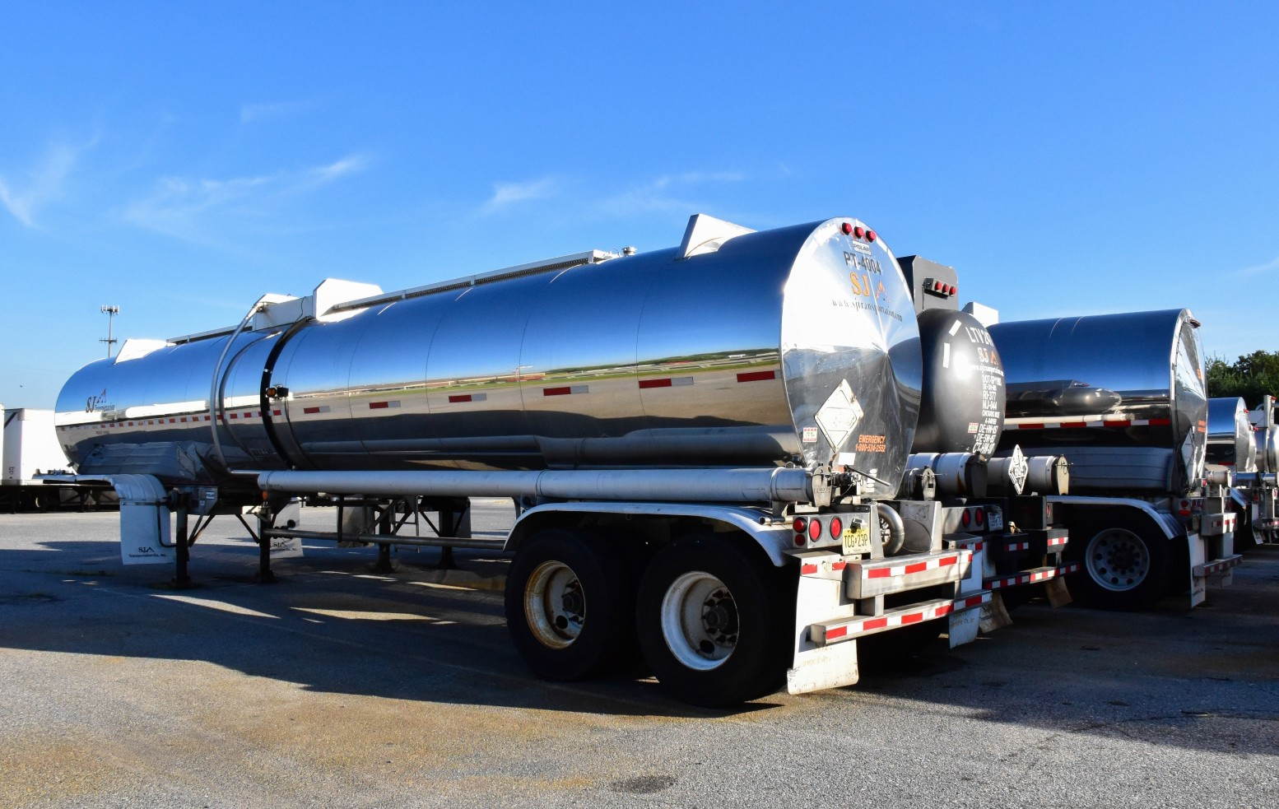

NEITI 2021 OIL AND GAS INDUSTRY REPORT

Nigeria Extractive Industries Transparency Initiative

5
NEITI 2021 OIL AND GAS INDUSTRY REPORT
Extractive
Industries

Initiative

1.
Background

Nigeria Extractive Industries Transparency Initiative (NEITI) engaged the services of Messrs Taju Audu & Co. as the Independent Administrator (IA) for the NEITI Oil & Gas Industry Report – 2021 themed “Relevance built on revenue growth and impact: improving revenue generation.” This report is prepared in line with the Extractive Industries Transparency Initiative (EITI) Standard 2019 and the Nigeria Extractive Industries Transparency Initiative (NEITI) Act, 2007. It consists of nine Sections, listed below:

EXECUTIVE
Summary

- Executive Summary
- Introduction
- The Oil and Gas Sector in Nigeria
- Exploration, Production and Export
- Revenue Collection and Reconciliations
- Cash Calls
- Downstream Operations
- Infrastructure Provisions, Barter Arrangement, Social and Economic Spending
- Outcomes and Impact

This report should be read along with the appendices, contextual information on NEITI website and within the context of the Petroleum Act, 1969 (as amended) which was the primary oil and gas legislation when the activities that generated the revenue took place. However, with the enactment of the Petroleum Industry Act (PIA) in August 2021, the report should also be read in the context of the various legislations as stated in the relevant Sections.

2.
Objectives

The key objectives of the audit include the following:
- To review and provide an overview of processes within the sector.
- To conduct an independent assessment of financial transactions (receipts and payments) and make recommendations to further improve transparency and accountability within the sector.

3.
Scope and Materiality

A total of 13 revenue streams with a minimum contribution of 1.5% of total revenue were found to be material for reconciliation at scoping (See Appendix 1 for scoping study report). However, ten other revenue streams were included in the scope of the report and reconciled on the basis of Section 3(f) of the NEITI Act. Consequently, all revenue streams except NESS Fees, PAYE and Miscellaneous Income were reconciled by the IA.

A total of 69 companies and the Nigeria Liquefied Natural Gas (NLNG) were covered in this report. Twenty-two out of 69 companies fell within the criteria for reconciliation and their payments represented 95.65% of total payment by companies. Thirteen government entities and one State-owned enterprise (SOE) were also covered.

Nigeria

6
NEITI 2021 OIL AND GAS INDUSTRY REPORT
Extractive
Industries

Initiative

4. Key Highlights of the 2021 Oil and Gas Audit Report
Table 1: Key Highlights of the 2021 Oil and Gas Audit Report

Country | Nigeria
Fiscal Period Covered | 2021
Sector Covered | Oil and Gas
Type of Audit | Financial, Physical and Process
2021 Audit Theme | “Relevance built on revenue growth and impact: improving revenue generation.”
Independent Administrator | Taju Audu & Co. (Chartered Accountants)

Entities Covered  •Section 1.4 | Total number of companies - 69
Entities Covered  •Section 1.4 | Companies Within the Materiality Threshold – 22
Entities Covered  •Section 1.4 | Government Entities (including SOE)- 13
Entities Covered  •Section 1.4 | Other entities - 2

Revenues covered  •Section 1.4 | Number of revenue streams - 23
Revenues covered  •Section 1.4 | Revenue streams reconciled - 20
Revenues covered  •Section 1.4 | Revenue streams unilaterally disclosed - 3
Revenue payments | Sale of crude oil and gas (less NNPC in-kind) | US$8.098billion (35.14%)
•Section 4.5 | Taxes and other specific flows | US$13.939billion(60.48%)
•Section 4.5 | Payment to sub-national entities | US$1.009billion (4.38%)
•Section 4.5 | Total Revenue | US$23.046billion (100%)

Reconciliation position  •Section 4.4 | Reconciled Revenue | US$21,648,054,000 (93.94%)
Reconciliation position  •Section 4.4 | Unreconciled Revenue | US$7,808,000 (0.03%)
Reconciliation position  •Section 4.4 | Unilaterally disclosed Revenue | US$1,390,226,000 (6.03%)
Total Revenue |  | US$23,046,088,000 (100%)

Analysis and distribution of total revenue  (value and proportion)  •Section 4.7 | Analysis of Total Revenue
 | Unremitted revenue by SOE | US$1,951,115,000 (8.47%)
 | Quasi-fiscal expenditure by SOE | US$6,931,285,000 (30.08%)
 | Sub-national payments | US$963,629,000 (4.18%)
 | Transfers to the Federation | US$13,200,059,000 (57.27%)
Total revenue |  | US$23,046,088,000 (100%)

Contribution of Oil and Gas to the Economy  •Section 7.4 | Federation Revenue Distribution
Contribution of Oil and Gas to the Economy  •Section 7.4 | 9 Oil producing States | 13.00%
Contribution of Oil and Gas to the Economy  •Section 7.4 | Federal Government | 52.68%
Contribution of Oil and Gas to the Economy  •Section 7.4 | States | 26.72%
Contribution of Oil and Gas to the Economy  •Section 7.4 | Local Governments | 20.60%
Contribution of Oil and Gas to the Economy  •Section 7.4 | Country GDP | US$434.17billion
Contribution of Oil and Gas to the Economy  •Section 7.4 | Contribution of Oil and Gas to GDP | 7.24%
Contribution of Oil and Gas to the Economy  •Section 7.4 | Country total exports | US$36.55billion
Contribution of Oil and Gas to the Economy  •Section 7.4 | Contribution to exports | 76.22%
Contribution of Oil and Gas to the Economy  •Section 7.4 | Total number of employees declared | 19,171

Fiscalised Crude oil production by arrangements (volumes and proportions)  •Section 3.2.1 | Joint Ventures ( Jvs)- including MCA & RA | 225,230.00mbbls (39.78%)
 | Production Sharing Contracts (PSCs) | 242,956.55mbbls (42.92%)
 | Service Contracts (SCs) | 978.89mbbls (0.17%)
 | Sole Risks (SRs) | 80,293.90mbbls (14.18%)
 | Marginal Fields (Mfs) | 16,670.61mbbls (2.94%)
 | Total fiscalised crude oil production | 566,129.94mbbls

Nigeria

7
NEITI 2021 OIL AND GAS INDUSTRY REPORT
Extractive
Industries

Initiative

4. Key Highlights of the 2021 Oil and Gas Audit Report
Table 1: Key Highlights of the 2021 Oil and Gas Audit Report

Country | Nigeria
Gas production  (volumes and proportion)  •Section 3.2.2 | Joint Ventures ( JVs) | 1,490,096.85mmscf | (54.31%)
Gas production  (volumes and proportion)  •Section 3.2.2 | Production Sharing Contracts (PSCs | ) 609,589.49mmscf (22.21%)
Gas production  (volumes and proportion)  •Section 3.2.2 | Service Contracts (SCs) | -
Gas production  (volumes and proportion)  •Section 3.2.2 | Sole Risks (SRs) | 561,288.67mmscf (20.46%)
Gas production  (volumes and proportion)  •Section 3.2.2 | Marginal Fields (MFs) | 82,725.31mmscf (3.02%)
Gas production  (volumes and proportion)  •Section 3.2.2 | Total Gas production | 2,743,700.32mmscf

Summary of issues/ findings from the Audit  •Section 8. | 1.Crude oil losses due to theft, sabotage and measurement errors
Summary of issues/ findings from the Audit  •Section 8. | 2.PMS subsidy and other quasi-fiscal expenditures
Summary of issues/ findings from the Audit  •Section 8. | 3.Unremited/under-remitted federation revenues by the SOE and companies
Summary of issues/ findings from the Audit  •Section 8. | covered in the 2021 audit
Summary of issues/ findings from the Audit  •Section 8. | 4.NPDC related issues of cash call funding and asset takeover
Summary of issues/ findings from the Audit  •Section 8. | 5.Misapplication of 13% derivation principle
Summary of issues/ findings from the Audit  •Section 8. | 6.Issues related the PIA and sector governance
Summary of issues/ findings from the Audit  •Section 8. | 7.Issues related to crude oil and gas barter arrangements
Summary of issues/ findings from the Audit  •Section 8. | 8.NEITI Audit remediation issue

Exchange rate for the Audit
₦399.68 CBN official average exchange rate for 2021

