2019 Work Plan Evaluation Report.


NIGERIA EXTRACTIVE INDUSTRIES TRANPARENCY INITIATIVE.
NO.60 NELSON MANDELA STREET, OFF KWAME NKRUMAH ASOKORO ABUJA.

Mohammed Buba

Contents

Introduction 3
Overall Objective 3
2019 Work Plan Objectives 3
The NEITI Strategic objectives are: 3
Core National Priority Objectives 4
Evaluation Methodology 4
Basis of Evaluation 4
Executive Summary 5
Figure 1: General Performance chart 5
Objectives Implementation Evaluation. 6
Figure 2: Objectives Evaluation Chart 7
General Performance Trend Analysis (5 years) 8
Risk Factors 9
Mitigation Factors 9
Work Plan Activities Status 10

Introduction

The 2019 work plan outlined detailed action plans and clearly mapped performance indicators that are time bound developed to guide the successful implementation of the NEITI strategic objective during the year. The work plan was developed in accordance with the key requirement of EITI reflecting national priorities and inputs from Government, Companies and the Civil Societies.

Overall Objective

The evaluation report objective is to assess the level of compliance and implementation of the work plan within the reporting period. The purpose is to ensure optimum compliance with the requirement 1.5 of the EITI standard, and to sustain the international best practice &process of performance review and level of implementation within the reporting year.

2019 Work Plan Objectives

The 2019 NEITI Work Plan was developed to consolidate on the change mantra of the FGN in ensuring transparency and accountability in the management and application of public resources.

The NEITI Strategic objectives are:
- Deepen openness in the extractive sector through timely audits and other impactful studies.

- Shape extractive sector and overall governance reforms through policy engagements, thought leadership and inter-agency coordination.

- To strengthen accountability in the use of extractive revenues through strategic communication with critical stakeholders and empowerment of accountability actors.

- To develop operational capacity, legitimacy and support through effective administration and human resource management and adequate funding.

Core National Priority Objectives

The National priority objectives of the Federal Government of Nigeria include:

- Economic Diversification
- Corporate governance and Anti-corruption
- State and Regional Development
- Infrastructure and Social Development
- Environmental protection

The work plan is strategically developed and aligned to meeting the national core priority objectives in the areas of National Economic Diversification and Improving Corporate Governance and anti-corruption reforms in addition to:

- Deepen the ongoing transparency and accountability drive in the extractive sector.
- Ensure International best practice in EITI Implementation, governance and resource management.
- Promote the needed debate and advocacy for reforms in the country’s extractive industry

Evaluation Methodology

Modified Logical Framework Analysis (MLFA) was adopted for the 2018 work plan Evaluation. The template was populated on the basis of the 2018 approved work plan.
The work plan activities were evaluated on the basis of the information supplied by departments in filling the MLFA template and absolute conformity with the NEITI Financial Guidelines.
Activities evaluated were not necessarily completed within the Scheduled time frame as in the work plan but were completed within the Reporting period.

Basis of Evaluation

- Activities were measured on the basis status (i.e. not started, in progress or completed) within the reporting period.

- Simple average of activities were taken to determine the success or otherwise of activities on % basis. (i.e.) number of activities in a status divided by the Total number of year activities multiplied by hundred.

- Activities are considered “Completed” when they are delivered within the reporting period.

- Activities are considered ‘In Progress’ where financial commitments are made and deliverables are not completed during the reporting period.

- Activities are considered not ‘started ‘Where it has not commenced as at reporting period.

Executive Summary

The 2019 General performance evaluation of the NEITI work plan covers the period January- December 2019. The overall performance report indicates that 70% of the activities were completed, 18% in progress and 12% not started as at reporting period.
The 2019 evaluation shows a slight performance improvement in all aspect of the work plan implementation

The General performance of the 2019 work plan implementation is represented in the diagram below.

Figure 1: General Performance chart
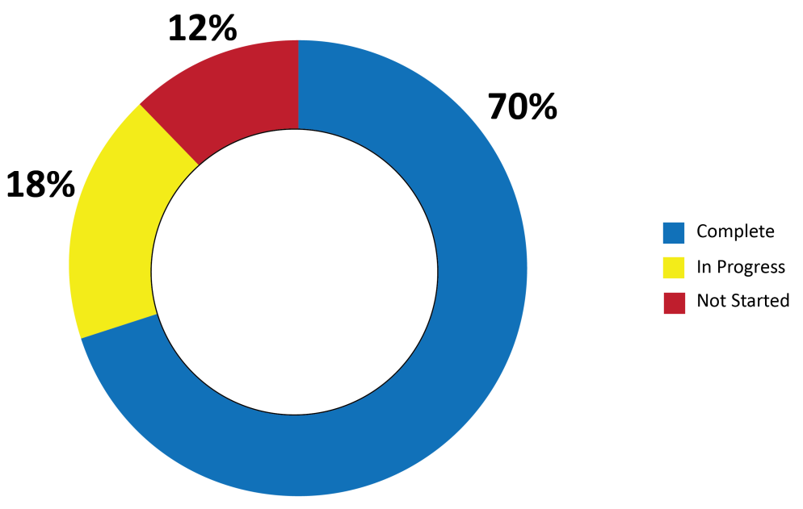

Objectives Implementation Evaluation.

The Objectives Evaluation Indicates that Objective 4 was implemented to the later, by providing the required legitimacy, human and financial support for the implementation of the NEITI 2019 work plan activities in accordance with the EITI principles in Nigeria.
Almost 100% activities designed under this objective are completed within the reporting period. The enhanced support in operational capacity, legitimacy was achieved through effective administration and human resource management despite the funding constraints in timely allocation by the FGN.

Objective 3 indicates that 57.1% of the planned activities within the reporting period were completed 14.3% in Progress and 28.6 % not implemented (NOT STARTED).
The process of strengthen accountability in the use of extractive revenues through strategic communication with critical stakeholders and empowerment of accountability actors require multi-dimensional approach as such stakeholders buy is more desirable in broadening and deepening the process.
However the communication with strategic stakeholders has steadily improved through routine outreach strategy and collaboration.
Objective 2 indicates that 66.7% of the planned activities were completed 27.8% in progress and 5.5% not started as at the reporting period. This is as a result of the research being conducted that are beyond the reporting period and other studies that require inter agency collaboration and support, in addition to limited funding to commence the research in time which is evidently clear that most of the research are donor funds supported.
Objective 1 indicates that 70% of the planned activities were completed, 20% are in progress and 10% are not implemented (Not Started); these activities however are Data automation related which is lacking the funding support to implement as at the reporting period.
However significant progress was made with the completion of the 2017 industry audits and the FASD within the reporting period.
Emerging issues in the EITI implementation such as Data Mainstreaming, Commodity Trading and Beneficial ownership disclosure register were also completed and lunched within the reporting dates.

Table 1
Strategic Obj | 1 | 2 | 3 | 4
Completed | 70% | 66.7% | 57.1% | 100%
In progress | 20% | 27.8% | 14.3% | -
Not started | 10% | 5.5% | 28.6% | -

Figure 2: Objectives Evaluation Chart

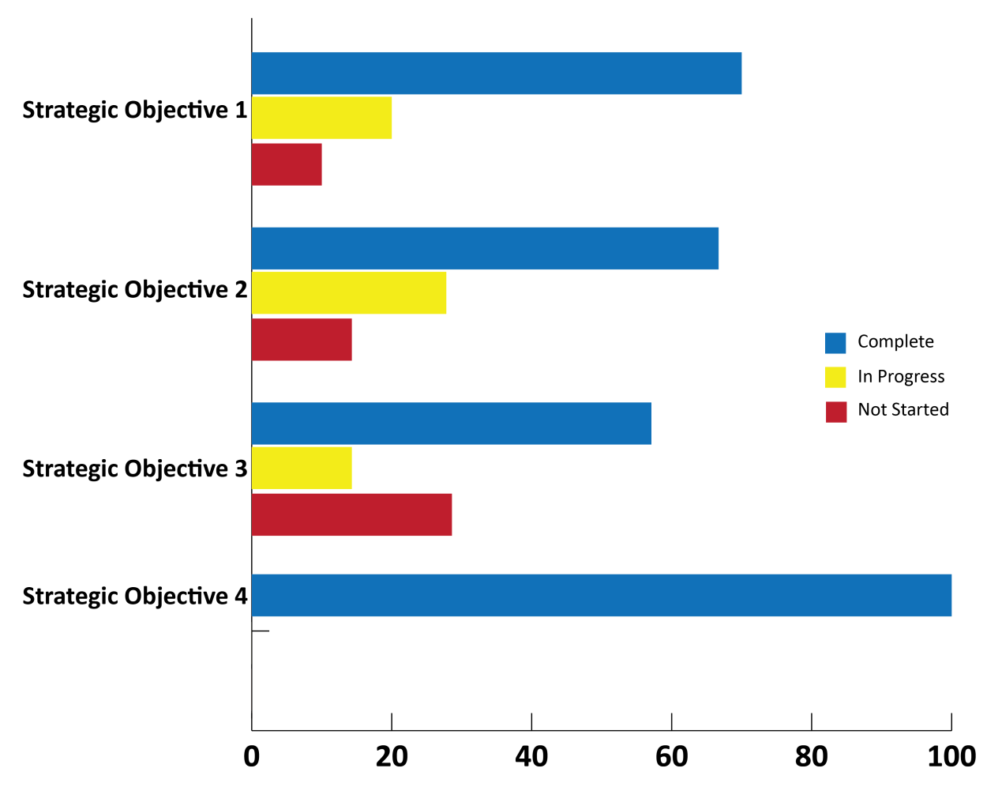

Table 2

General Performance Trend Analysis (3 years)

YEAR | COMPLETED % | IN PROGRESS % | NOT STARTED %
2017 | 62.85 | 20 | 17.15
2018 | 68 | 19 | 13
2019 | 70 | 18 | 12

Figure 3: 5 years General Performance Trend Analysis

The 5 years trend analysis shows stability in the activities from the year 2015-2019 i.e. 71.5% -70%, a slight increase in the activities in progress from 14.8%-18% and a hairline reduction in the activities that have not started, 13.9% - 12%.
The 3 years trend analysis shows a slight increase in the activities implemented between 2017 – 2019 (62.85% - 70%)and a slight reduction in the activities in progress (20% - 18%) and not started (17.15% - 13%).
Generally the year 2019 has been very successful with a positive outlook in 2020.

Risk Factors

NEITI critical success factors in the implementation of our 2018 set objectives are:

- Funding: Funding has been the major success factor in achieving our mandate thus its timely and regular availability and accessibility will aid successful implementation of our programs and objectives.

- Management buy in in the evolution process of domesticating monitoring and evaluation at all level in the organization.

- Limited capacity of personal in the Monitoring and evaluation unit.

Mitigation Factors

- Donor Funding: NEITI will continue to approach our partners and willing donors to support our programs. Currently the World Bank, Trust Africa and the Ford Foundation have agreed to support some of our projects.

- Management to set out session for work plan development, the Planning Monitoring &Evaluation unit is to develop template to fit into strategic goal of NEITI to meet the EITI requirement.

- Capacity building is required for focal persons at departmental level to aid effective work plan development and Monitoring & Evaluation functions ion at the various levels.

Work Plan Activities Status

S/n | Activity | Objective | Start/End Month | KPI | Status of Activity  (Items remove from WP should be mark not started.) |  |  | Outcome
 | From work plan | Strategic | From work plan | From work plan | Not Started | In Progress | Completed | As stated in the work plan
1.1 | 2017 Oil &Gas Industry Audit | Deepen openness in the extractive sector through timely audits and other impactful studies | Jan-Dec 19 | Approved  Oil & Gas Report |  |  |  | O&G Report
1.2 | 2017 Solid Minerals Industry Audit |  | Jan-Dec 19 | Approved SM Report |  |  |  | SM Report
1.3 | FASD Audit 2012-2016 |  | Jan-Dec 19 | Approved FASD Report |  |  |  | FASD Report
1.4 | Conduct gap analysis of available and potential data from relevant MDA required for mainstreaming |  | Jan-Dec 19 |  |  |  |  | Improve Audit Process
1.5 | Organise interactive sessions with relevant government agencies regarding outstanding data ( in open format to be hosted on websites of relevant agencies) for the purpose of mainstreaming. |  | Jan-Dec 19 |  |  |  |  | No. of Reforms Initiated as a result of the Remediation
1.6 | Capacity building for relevant staff of MDA on their role in mainstreaming data. |  | Jan-Dec 19 |  |  |  |  | No. of Reforms Initiated as a result of the Remediation
1.7 | Conduct an assessment of the impact of the SM Roadmap Implementation (from the Sector Governance and Revenue generation perspectives) from inception to date) |  | Jan-Dec 19 |  |  |  |  | No. of Reforms Initiated as a result of the Remediation
1.8 | Design and Develop Data Automation System |  | Jan-Dec 19 |  |  |  |  | Automated data collection system
1.9 | Beneficial Ownership Disclosure Register. |  | Jan-Dec 19 |  |  |  |  | Beneficial Ownership Register
1.10 | Commodity Trading Pilot scheme studies |  | Jan-Dec 19 |  |  |  |  | Study Report
 | Summary Objective 1 |  |  |  | 1/10  (10%) | 2/10  20% | 7/10  70%

S/n | Activity | Objective | Start/End Month | KPI | Status of Activity  (Items remove from WP should be mark not started.) |  |  | Outcome
 | From work plan |  | From work plan | From work plan | Not Started | In Progress | Completed | As stated in the WP
2.1 | Manage and Track Implementation of Remediation Action Plan Items from Previous Audit(s) | Shape extractive sector and overall governance reforms through policy engagements, thought leadership and inter-agency coordination | Jun-Dec | Platform for anti-corruption database developed |  |  |  | No. of remediated issues resolve
2.2 | Track and Recommend Steps on Policy Issues from the Audits |  | Jun-Dec | Report |  |  |  | No. of policy papers issued
2.3 | Outcome Assessment of all Remediation Activities |  | Jun-Dec | Annual Report |  |  |  | Remediation Report
2.4 | Update the developed framework (by PPS) for remediation with active participation of TUGAR and anti-corruption agencies |  | Jun-Dec | Report of meetings and reforms |  |  |  | Updated Framework for remediation
2.5 | Round Table engagements on Recommendations from Audits for Oil and Gas, Solid Minerals and FASD | Shape extractive sector and overall governance reforms through policy engagements, thought leadership and inter-agency coordination | Jun-Dec | No. of reforms initiated. |  |  |  | Reports
2.6 | Application of 13% derivation in selected Niger Delta communities |  | Jan-Mar 20 | Application Report |  |  |  | Studies Report
2.7 | Research: (4 FAAC quarterly reviews, 1 occasional paper, 2 policy briefs & 1 occasional paper) |  | Mar-Dec | Policy Briefs, Q. Reviews & Papers produced |  |  |  | Policy Papers reviews & research.
2.8 | Economic and Environmental Impact of Small Scale Mining Activities in Some Selected States |  | Mar 19 | Mining Impact report |  |  |  | Studies Report
2.9 | Policy dialogues (NEITI Validation, Mining/13% derivation, Reforms in the extractive sector, PIB[4-in1], and Contract Transparency |  | Dec 19 | No. Of Policy dialogue hosted |  |  |  | Reports
2.10 | Review of Existing Reforms in the Oil & Gas Sector |  | Dec 19 | Reviews report |  |  |  | Industry reforms recommended
2.11 | Research on the Impact of Decline in the Prices of Crude Oil on the Oil and Gas Sector |  | Jun 19 | Research Report |  |  |  | Report
2.12 | Development of 2019 Annual work plan & 2020 Budget. |  | Jan & Sept | Work Plan & Budget Developed |  |  |  | Work Plan & Budget Developed
2.13 | Implementation of M&E Framework |  | Jan- Dec | M&E report |  |  |  | Finalized Framework
2.14 | Development of 2018 EITI Annual Activity Report |  | Jun 19 | APR Produced |  |  |  | EITI APR Report
2.15 | Review of Nigeria's Implementation of the UNCAC (2nd Cycle) and implementation of the Remediation Plan for the 1st & 2nd review Cycle |  | Jan-Dec | Report and Action Plan |  |  |  | Action Plan for implementation
216 | Implementation / Monitoring and Evaluation of the National Anti-Corruption Strategy NACS |  | Jan- Dec | Annual Report |  |  |  | Reduced Corruption Index %
2.17 | Corruption Risk Assessment in the Nigerian Ports - Implementation of Integrity Plan |  | Jan – Dec | Level of Integrity plan Implementation. |  |  |  | Level of Integrity plan Implementation
2.18 | Implementation of findings of Scoping Survey / Gap Analysis of the Ethics Framework in Nigeria |  | Jan- Dec | Report |  |  |  | Ethics Report
 | Summary Objective 2 |  |  |  | 1/18  5.6% | 5/18  27.8% | 12/18  66.7%

S/n | Activity | Objective | Start/End Month | KPI | Status of Activity  (Items remove from WP should be mark not started.) |  |  | Outcome
 | From work plan |  | From work plan | From work plan | Not Started | In Progress | Completed | As stated in the work plan
3.1 | Simplification of NEITI Industry Audit reports -Oil, gas, solid minerals and FASD with infographics | To strengthen accountability in the use of extractive revenues through strategic communication with critical stakeholders and empowerment of accountability actors. | Apr-Jun | Country report and action plan No. of reforms
3.2 | Simplification of NEITI Industry Audit reports -in brail language with infographics |  | Sept. | IATT meetings
3.3 | Validation workshop on the simplified brail language report |  | Oct | AC Day Celebrations
3.4 | Public presentation of the NEITI Industry Audit reports |  | Sept | Signed Contract
3.5 | Production of NEITI branded materials for outreach activities |  | Jan-Dec
3.6 | Presentation of the NEITI reports in the geo-political zones |  | Jun-Nov | Minutes Of Meetings
3.7 | Sensitization workshop on natural resource governance to the Legislature | To strengthen accountability in the use of extractive revenues through strategic communication with critical stakeholders and empowerment of accountability actors. | Jun- sept | Resolve Issues from the Report
3.8 | Workshop for state exco s and states assemblies on natural resource governance and domestication of the EITI in 6 geo-political zones. |  | May- Dec
3.9 | Town hall meetings with LGA excos, opinion/Community leaders/NGOs/CSOs/FBOs in the 6 geo-political zones. |  | May-Nov
3.10 | Youth/ Student Outreach on EITI in 6 Universities /Polytechnic/Colleges of education across 6 geo-political zones. |  | Apr-Nov | Resolve Issues from the Report
3.11 | Capacity building for Civil Society Organisations. |  | Jun-Nov | Policy Document
3.12 | Capacity building for the Media. |  | Jun- Nov | Reviewed Act
3.13 | Capacity building for the Professional Bodies. |  | Jun-Nov | Developed WP
3.14 | Capacity Building Videography Specialist. |  | Sept. | M&E Reports
 | Summary Objective 3 |  |  |  | 4/14  28.6% | 2/14  14.3% | 8/14  57.1%

S/n | Activity | Objective | Start/End Month | KPI | Status of Activity  (Items remove from WP should be mark not started.) |  |  | Outcome
 | From work plan |  | From work plan | From work plan | Not Started | In Progress | Completed | As stated in the work plan
4.1 | General Administration & support | To develop operational capacity, legitimacy and support through effective administration and human resource management and adequate funding. | Jan- Dec | Improved Admin system |  |  |  | Improved admin services
4.2 | Human Resource Management & Capacity Building |  | Jan- Dec | Staff Capacity building & skills. |  |  |  | Staff Capacity building & skills.
4.3 | Information Technology Support |  | Jan- Dec | Effective IT Support System |  |  |  | Effective IT Support System
4.4 | Audit and Control |  | Jan- Dec | Improved Control system |  |  |  | Improved Control system
4.5 | Procurement & Services |  | Jan- Dec | Effective & timely Procurement. |  |  |  | Effective & timely Procurement.
4.6 | Finance & account Support |  | Jan- Dec | Effective Finance & Financial Support |  |  |  | Effective Finance & Financial Support
4.7 | Monitoring & Evaluation |  | Jan- Dec | Improved System and Processes |  |  |  | Improved System and Processes
4.8 | Legal Service & Compliance Support. |  | Jan- Dec | Timely compliance and Legal support |  |  |  | Timely compliance and Legal support
 | Summary Objective 4 |  |  |  | 0% | 0% | 100%

Strategic Objectives | Completed | In Progress | Not Started | Total
Objective 1 | 7 | 2 | 1 | 10
Objective 2 | 12 | 5 | 1 | 18
Objective 3 | 8 | 2 | 4 | 14
Objective 4 | 8 | - | - | 8
Total | 35 | 9 | 6 | 50
% of Performance | 70% | 18% | 12%

