2020 Work Plan Evaluation Report.


NIGERIA EXTRACTIVE INDUSTRIES TRANPARENCY INITIATIVE.
NO.60 NELSON MANDELA STREET, OFF KWAME NKRUMAH ASOKORO ABUJA.

Planning Policy & Strategy Dept

Contents

Executive Summary: 3
Strategic Objectives Performance Review 3
Figure 1: General Performance chart 4
Introduction 5
Overall Objective 5
2020 Work Plan Objectives 5
The NEITI Strategic objectives are: 5
Core National Priority Objectives 6
Evaluation Methodology 6
Basis of Evaluation 7
Executive Summary 7
Figure 1: General Performance chart 7
Objectives Implementation Evaluation. 8
Figure 2: Objectives Evaluation Chart 9
General Performance Trend Analysis (3 years) 10
Risk Factors 11
Mitigation Factors 11
Work Plan Activities Status 12
Conclusion 18

Executive Summary:
The 2020 NEITI work plan performance evaluation covers the period January- December 2020. The overall performance report indicates that 73% of the activities were completed, 23% in progress and 4% not started as at reporting period.
The 2020 evaluation shows a slight performance improvement in all aspect of the work plan implementation despite the effect of the COVID 19 pandemic on the global economy.

Strategic Objectives Performance Review

Objective 1: Activity review indicates that 68.75% of the planned activities were completed, 25% are in progress and 6.25% are not implemented (Not Started.)
Significant progress was made with the completion of the 2018 & 2019 industry audits and the FASD within the reporting period.
Partnership was also achieved by the establishment of the NEITI/NNPC joint remediation committee in addressing most of the outstanding issues that frequent the Oil & Gas industry audit report recommendations.
Emerging issues in the EITI implementation such as Data Mainstreaming pilot study, Commodity Trading and Beneficial ownership disclosure implantation was also carried out.
Objective 2: Evaluation shows that 73.7 % of the planned activities were completed 26.3% in progress as at the reporting period. This is because of the research being conducted that are beyond the reporting period, and other studies that require inter-agency collaboration and support. There was also limited funding to commence the research activities in some cases as planned.
Objective 3: Indicates that 61.5% of the planned activities was implemented within the reporting period 7.7 % is in Progress and 30.8 % not implemented (NOT STARTED).
The activities designed to implement strategic communication with critical stakeholders aimed at empowering accountability actors were conducted using a multi-dimensional approach. Adequate stakeholders buy-in are expected to broaden and deepen the process of extractive industry transparency and accountability in Nigeria.
Communication with strategic stakeholders relatively improved through routine outreach activities and strategic engagement.
Objective 4: The Objectives Evaluation Indicates that activities designed to achieve Objective 4 within the reporting period achieved 100% implementation, this encouraging performance is due to availability of the required human and financial support received during the implementation of the NEITI 2020 work plan activities in accordance with the EITI principles.
Activities designed under this objective are completed within the reporting period. Enhanced operational capacity was achieved through effective administration with limited capacity development due to the funding constraints in timely allocation by the FGN.

The General performance of the 2020 work plan implementation is represented in the diagram below.

Figure 1: General Performance chart
Figure 1 General Performance Chart

Introduction
The 2020 work plan is NSWG approved document guiding the Nigeria EITI implementation of the year’s activities. The document outlined detailed action plans and clearly mapped performance indicators that are costed and time bounded. The work plan was carefully developed in accordance with the key requirement of EITI reflecting national priorities and inputs from Government, Companies, and the Civil Societies.

Overall Objective

The objective of the evaluation report is to assess the extent of the implementation of our 2020 work plan comparatively in achieving our 4 strategic long-term objectives within the reporting period.
The monitoring and evaluation are conducted in line with the NEITI M&E framework, compliance with the requirement 1.5 of the EITI standard, and the international best practice & process of performance review within the reporting year.

2020 Work Plan Objectives

The 2020 NEITI Work Plan was tailored to consolidate the gains and deepen the process of EITI implementation in Nigeria by ensuring transparency and accountability in the management and application of extractive revenues for public good.

The NEITI Strategic objectives are:
- Deepen openness in the extractive sector through timely audits and other impactful studies.

- Shape extractive sector and overall governance reforms through policy engagements, thought leadership and inter-agency coordination.

- To strengthen accountability in the use of extractive revenues through strategic communication with critical stakeholders and empowerment of accountability actors.

- To develop operational capacity, legitimacy and support through effective administration and human resource management and adequate funding.

Core National Priority Objectives

The National priority objectives of the Federal Government of Nigeria include:

Socio Economic Priority:
- Achieve Macroeconomic stability
- Improve efficiency & quality of capital spending on critical Infrastructures and maintain 7% GDP Growth
- Broaden Revenue base, plug leakages and reduce fiscal deficit by 3% of GDP
Governance:
- Improve on Governance and Reform initiatives
- Intensify Fight against corruption
- Improve Fiscal disciple in management of public spending
Environment:
- Improve Eco friendly environment

The 2020 work plan is purposefully designed to support the national core priority objectives of governance by improving in governance and reform initiatives, amplified the fight against corruption and improve fiscal discipline in management of public spending. The plan will also support Socio Economic Priority of the FGN to achieve Macroeconomic stability, improve efficiency & quality of capital spending on critical Infrastructures and maintain 7% GDP Growth, Broaden Revenue base, plug leakages and reduce fiscal deficit by 3% of GDP among other priority objectives.

Evaluation Methodology

Modified Logical Framework Analysis (MLFA) was adopted for the 2020 work plan Evaluation. The template was populated based on the 2020 approved work plan.
The work plan activities were monitored, implementation data collected and evaluated based on the information supplied by departments in filling the MLFA template and absolute conformity with the NEITI Financial Guidelines.
Activities evaluated were not necessarily completed within the scheduled time frame as in the work plan but were completed within the reporting period.

Basis of Evaluation

- Activities were measured on the basis status (i.e. not started, in progress or completed) within the reporting period.

- Simple average of activities were taken to determine the success or otherwise of activities on % basis. (i.e.) number of activities in a status divided by the Total number of year activities multiplied by hundred.

- Activities are considered “Completed” when they are delivered within the reporting period.

- Activities are considered ‘In Progress’ where financial commitments are made, and deliverables are not completed during the reporting period.

- Activities are considered not ‘started ‘Where it has not commenced as at reporting period.

General Performance Table.

Table 1
Strategic Obj | 1 | 2 | 3 | 4
Completed | 68.75% | 73.7% | 61.5% | 100%
In progress | 25% | 26.3% | 7.7% | -
Not started | 6.25% | - | 30.8% | -

Figure 2: Objectives Evaluation Chart

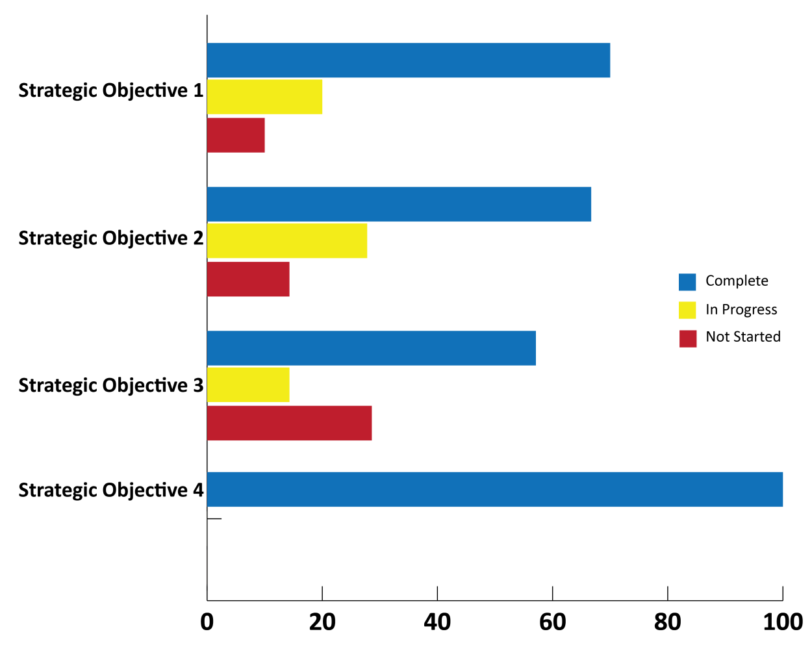

Table 2

General Performance Trend Analysis (3 years)

YEAR | COMPLETED % | IN PROGRESS % | NOT STARTED %
2018 | 68 | 19 | 13
2019 | 70 | 18 | 12
2020 | 73 | 23 | 4

Figure 3: 3 years General Performance Trend Analysis
(2018-2020)

The 3 years trend analysis shows relative improvement in the activity’s completion from the year 2018-2020 i.e. 68%, 70% and 73% respectively. 70%, significantly, there has been reduction in level of activities not started from 13%,12% and 4% in 2020. This could be attributed to effective and efficient planning and implementation of the workplan.
The year 2020 has been most challenging considering the effect of COVID 19 on the global economy and its adverse consequence.
New order has been explored with virtual technology to improve on the plans and activities. In general terms activities considered to be in progress has substantial financial commitment and in many cases their implementation will exceed one fiscal year.

Risk Factors

NEITI critical success factors in the implementation of our 2020 set objectives are:

- Funding: Funding has been the major success factor in achieving our mandate thus its timely and regular availability and accessibility will aid successful implementation of our programs and objectives.

- Management buys in the evolution process of domesticating monitoring and evaluation at all level in the organization.

- Limited capacity of personal in the Monitoring and evaluation unit.

- Challenges of coping with the new world order on the COVID 19 protocol thus need to heavily invest in technology to support the virtual process.

Mitigation Factors

- Donor Funding: NEITI will continue to approach our partners and willing donors to support our programs. Currently the World Bank, Ford Foundation, Rolac and the GIZ are supporting NEITI in the EITI implementation.

- Management to set out session for work plan development, the Planning Monitoring &Evaluation unit is to develop template to fit into strategic goal of NEITI to meet the EITI requirement.

- Capacity building is required for focal persons at departmental level to aid effective work plan development and Monitoring & Evaluation functions ion at the various levels.

Work Plan Activities Status

S/n | Activity | Objective | Start/End Month | KPI | Status of Activity  (Items remove from WP should be mark not started.) |  |  | Outcome
 | From work plan | Strategic | From work plan | From work plan | Not Started | In Progress | Completed | As stated in the work plan
1.1 | Oil and gas Reconciliation Report 2019 | Deepen openness in the extractive sector through timely audits and other impactful studies | Jan-Dec 20 | Approved  Oil & Gas Report |  |  |  | Oil &Gas Report
1.2 | Solid Minerals reconciliation report 2019 |  | Jan-Dec 20 | Approved SM Report |  |  |  | Solid Minerals Report
1.3 | FASD reconciliation report 2017- 2019 |  | Jan-Dec 20 | Approved FASD Report |  |  |  | FASD Report
1.4 | Scoping study for 2019 Oil and Gas reconciliation report |  | Jan-Dec 20 | O &G Scoped Report. |  |  |  | Improved Oil & Gas Audit Process & Report
1.5 | Scoping study for 2019 Solid Mineral reconciliation report |  | Jan- Apr 20 | SM Scoped Report |  |  |  | Improved SM Audit process & Report
1.6 | Scoping study for 2017-2019 FASD report |  | Jan-Apr 20 | FASD Scoped Report |  |  |  | Improved FASD Audit process & Report.
1.7 | Template review for Oil and Gas report |  | Jan-Apr 20 | Reviewed Template |  |  |  | Reviewed Oil & Gas template
1.8 | Template review for Solid Mineral report | Deepen openness in the extractive sector through timely audits and other impactful studies | Jan-Apr 20 | Reviewed Template |  |  |  | Reviewed Solid Mineral template
1.9 | Template review for 2017-2019 FASD report. |  | Jan-Jul 20 | Reviewed Template |  |  |  | Reviewed FASD Template
1.10 | Data Automation Infrastructure  Design and Develop Data Automation System, Testing  Deployment & Capacity Building |  | Jan-Dec 20 | Automated Data |  |  |  | Automated data collection system
1.11 |  |  | Jan-Dec 20 | Remediation action Plan |  |  |  | No. of Remediated actions taken.
  Identify Remediation Action Plan Items from Previous reconciliation(s) report
1.12 | Track recommended corrective steps on policy Issues from the reconciliations report |  | Jan-Dec 20 | Remediation report |  |  |  | No. of Policy papers issued
1.13 | Round Table engagements on recommendations from Oil, Gas, Solid Minerals and FASD reconciliation reports |  | Jan-Dec 20 | Remediation Report |  |  |  | No. of recommendations resolved
1.14 | The effect of the decline in the price of Crude Oil on investment in the upstream sector of the Oil & Gas industry in Nigeria. |  | Jan-Dec 20 | Study Report |  |  |  | Study Report
1.15 | Review of existing reforms in the Oil & Gas sector |  | Jan-Dec 20 | Reviewed Reforms |  |  |  | Reviewed Reforms
1.16 | Development of framework for Enforcement & Compliance with provisions of the NEITI Act as it concerns data collection from statutory agencies of government with a view to ensure timely disclosure by covered entities. |  | Jan-Dec 20 | Compliance Report |  |  |  | Developed framework
 | Summary Objective 1 |  |  |  | 1/16  (6.25%) | 4/16  25% | 11/16  68.75%

S/n | Activity | Objective | Start/End Month | KPI | Status of Activity  (Items remove from WP should be mark not started.) |  |  | Outcome
 | From work plan |  | From work plan | From work plan | Not Started | In Progress | Completed | As stated in the WP
2.1 | FAAC Data mining & Fiscal Modelling for Data Dashboard | Shape extractive sector and overall governance reforms through policy engagements, thought leadership and inter-agency coordination | Jun-Dec | Platform for anti-corruption database developed |  |  |  | No. of remediated issues resolve
2.2 | Remediation Developing a framework for Policy engagements on remedial actions by statutory agencies of government relating to timely disclosure and resolution by the entities |  | Jun-Dec | Report |  |  |  | No. of policy papers issued
2.3 | Oil & Gas Research: Post Application of 13% derivation studies in selected Niger Delta communities (Policy Dialogue) |  | Jun-Dec | Annual Report |  |  |  | Remediation Report
2.4 | Mining Research: Post Research on the social and economic impact of mining on women, youths, and other vulnerable groups in Nigeria (policy Dialogue) |  | Jun-Dec | Report of meetings and reforms |  |  |  | Updated Framework for remediation
2.5 | E.I Data Mainstreaming and Administration | Shape extractive sector and overall governance reforms through policy engagements, thought leadership and inter-agency coordination | Jun-Dec | No. of reforms initiated. |  |  |  | Reports
2.6 | BO Beneficial Ownership implementation. |  | Jan-Mar 20 | Application Report |  |  |  | Studies Report
2.7 | Research: (4 FAAC quarterly reviews, 1 occasional paper, 2 policy briefs & 1 occasional paper) |  | Mar-Dec | Policy Briefs, Q. Reviews & Papers produced |  |  |  | Policy Papers reviews & research.
2.8 | Organise interactive sessions on contract transparency/disclosure with relevant government agencies |  | Mar 19 | Mining Impact report |  |  |  | Studies Report
2.9 | Development of 2020 Annual work plan & 2021 Budget. |  | Jan & Sept | Work Plan & Budget Developed |  |  |  | Work Plan & Budget Developed
2.10 | 2020 Implementation of M&E Framework |  | Jan- Dec | M&E report |  |  |  | Finalized Framework
2.11 | Development of 2019 EITI Annual Activity Report |  | Jun 19 | APR Produced |  |  |  | EITI APR Report
2.12 | Review of Nigeria's Implementation of the UNCAC (2nd Cycle) and implementation of the Remediation Plan for the 1st & 2nd review Cycle |  | Jan-Dec | Report and Action Plan |  |  |  | Action Plan for implementation
2.13 | Follow up activities on TUGAR Ethics Survey and Gap Analysis |  | Jan- Dec | Report |  |  |  | Ethics & Gap Analysis report
2.14 | Implementation of the Integrity Plan in the MDG Related MDAs |  | Jan - Dec | Report |  |  |  | Implementation Report
215 | Implementation / Monitoring and Evaluation of the National Anti-Corruption Strategy NACS |  | Jan- Dec | Annual Report |  |  |  | Reduced Corruption Index %
2.16 | Corruption Risk Assessment in the Nigerian Ports - Implementation of Integrity Plan |  | Jan – Dec | Level of Integrity plan Implementation. |  |  |  | Level of Integrity plan Implementation
2.17 | Development and publication of the TUGAR Policy Briefs and stakeholder engagement on the brief |  | Jan- Dec | Report |  |  |  | Ethics Report
2.18 | Coordination of the Anti-Corruption Agencies on the platform of the IATT |  | Jan - Dec | IATT Meetings |  |  |  | No. of IATT meetings held
2.19 | Joint Commemoration of the International Anti-Corruption Day. |  | Dec | AC Day Celebrated |  |  |  | AC day held
 | Summary Objective 2 |  |  |  | 0 | 5/19  26.3% | 14/19  73..7%

S/n | Activity | Objective | Start/End Month | KPI | Status of Activity  (Items remove from WP should be mark not started.) |  |  | Outcome
 | From work plan |  | From work plan | From work plan | Not Started | In Progress | Completed | As stated in the work plan
3.1 | Simplification of NEITI Industry Audit reports -2017 Oil, gas, solid minerals and 2012-2016 FASD. | To strengthen accountability in the use of extractive revenues through strategic communication with critical stakeholders and empowerment of accountability actors. | Apr-Jun | Simplified Reports |  |  |  | Simplified Reports
3.2 | Simplification and visualisation of the fiscal regimes of Nigeria's extractive sector. |  | Sept. | Visual Report |  |  |  | Visual Report
3.3 | Dissemination of NEITI Reports to Stakeholders. |  | Oct | No. of stakeholder engagement on NEITI audit reports |  |  |  | No. of stakeholder engagement on report
3.4 | Publication of NEITI Reports. |  | Sept | Published Reports |  |  |  | Published reports
3.5 | Production of NEITI branded materials for outreach activities |  | Jan-Dec | Branded Materials produced |  |  |  | Branded Materials produced
3.6 | Presentation of the NEITI reports in the geo-political zones |  | Jun-Nov | Minutes Of Meetings |  |  |  | Minutes Of Meetings
3.7 | Sensitization workshop on natural resource governance to the Legislature | To strengthen accountability in the use of extractive revenues through strategic communication with critical stakeholders and empowerment of accountability actors. | Jun- sept | Resolve Issues from the Report |  |  |  | Resolve Issues from the Report
3.8 | Workshop for state exco s and states assemblies on natural resource governance and domestication of the EITI in 6 geo-political zones. |  | May- Dec | Workshop Reports |  |  |  | Workshop Reports
3.9 | Capacity building for communication officers of covered entities. |  | May-Nov | Trained Personnel |  |  |  | No. of Trained Personnel
3.10 | Subscription and management of NEITI online IEC Apps (REMTRACK; E-Learning portal; NEITI App; Online campaign adverts; etc |  | Apr-Nov | Resolve Issues from the Report | Active App and portal |  |  | Active remtrack App.
3.11 | Capacity building for Civil Society Organisations. |  | Jun-Nov | Policy Document | No. of trained CSO |  |  | No. of trained CSO
3.12 | Capacity building for the Media. |  | Jun- Nov | Reviewed Act | N. of trained Media |  |  | N. of trained Media
3.13 | Capacity building for the Professional Bodies. |  | Jun-Nov | Developed WP | No. of Trained PB |  |  | No. of Trained PB
 | Summary Objective 3 |  |  |  | 4/13  30.8% | 1/13  7.7% | 8/13  61.5%

S/n | Activity | Objective | Start/End Month | KPI | Status of Activity  (Items remove from WP should be mark not started.) |  |  | Outcome
 | From work plan |  | From work plan | From work plan | Not Started | In Progress | Completed | As stated in the work plan
4.1 | General Administration & support | To develop operational capacity, legitimacy and support through effective administration and human resource management and adequate funding. | Jan- Dec | Improved Admin system |  |  |  | Improved admin services
4.2 | Human Resource Management & Capacity Building |  | Jan- Dec | Staff Capacity building & skills. |  |  |  | Staff Capacity building & skills.
4.3 | Information Technology Support |  | Jan- Dec | Effective IT Support System |  |  |  | Effective IT Support System
4.4 | Audit and Control |  | Jan- Dec | Improved Control system |  |  |  | Improved Control system
4.5 | Procurement & Services |  | Jan- Dec | Effective & timely Procurement. |  |  |  | Effective & timely Procurement.
4.6 | Finance & account Support |  | Jan- Dec | Effective Finance & Financial Support |  |  |  | Effective Finance & Financial Support
4.7 | Monitoring & Evaluation |  | Jan- Dec | Improved System and Processes |  |  |  | Improved System and Processes
4.8 | Legal Service & Compliance Support. |  | Jan- Dec | Timely compliance and Legal support |  |  |  | Timely compliance and Legal support
 | Summary Objective 4 |  |  |  | 0% | 0% | 100%

WP Implementation Evaluation Summary Table
Strategic Objectives | Completed | In Progress | Not Started | Total
Objective 1 | 11 | 4 | 1 | 16
Objective 2 | 14 | 5 | 0 | 19
Objective 3 | 8 | 4 | 1 | 13
Objective 4 | 8 | - | - | 8
Total | 41 | 13 | 2 | 56
% of Performance | 73% | 23% | 4%

Conclusion
The 2020 implementation of the NEITI workplan has been successful despite the challenges of the COVID 19 on the global economy.
Nigeria EITI was able to produce policy papers, conduct policy dialogue and closed the gap in the industry audit reporting.

